SEAFOOD ANALYSIS

Issue: Concerns over the sustainability of the area’s wild seafood industry

Background:

A geographical area tracks various statistics that measure the performance of its seafood industry. Three important statistics include wholesale value, which is the amount a manufacturer charges a retailer for a product which will eventually be resold to an end user; landed value, which is the value of cargo when it is ready to be sold (and may be less than the value when it was shipped originally due to perishability); and landings, which measures the total amount of product that is produced.

A data set has been produced that gives yearly data from 1997 to 2017 of the three measures discussed above of the area’s seafood harvest broken down by the various products in the industry. According to this data set, for all seafood products in 2017, the wholesale value was $1,773.50M, the landed value was $1,203.20M, and the landings were 304,100 tonnes. Additionally, in 2017 farmed salmon accounted for the largest percentage of wholesale value (44%) and landed value (41%) and the second-highest percentage of landings tonnage (5%; behind groundfish, which accounted for 7% of the total landings in that year).

The total seafood harvest statistics in 2017 are shown in Table 1 in the Appendix of this document.

Discussion:

In recent years, concerns have grown about the performance and sustainability of the world’s wild seafood industry. It is well-known that wild seafood products are on the decline globally: for example, the journal *Science* published a report in 2016 predicting that the world will run out of edible seafood by 2048[1]. Analysis of the data set discussed above suggests that the area’s wild seafood industry is consistent with global trends and will likely decline in the future, especially in comparison to equivalent farmed products.

In the data set, three products are defined as “wild”: wild salmon, wild shellfish, and “other wild.” Similarly, three products are defined as “farmed”: farmed salmon, farmed shellfish, and “other farmed.” A direct comparison of the total of wild and farmed products indicates that farmed products compromise a much larger proportion of the area’s seafood industry than wild ones. For instance, in 2017, the ratio of wild to farmed products was 0.58:1 for wholesale value, 0.30:1 for landed value and 0.36:1 for landings.

Figure 1 in the Appendix of this document shows visually the time series of the three outcome measures, wholesale value, landed value and landings, as well as the ordinary least squares (OLS) regression lines, for farmed and wild products between 1997 and 2017. As can be seen from the figure, for all three measures the farmed products have increased at a much faster rate than those for the wild products. In fact, wild products’ wholesale value and landed values have mostly remained unchanged over the time period, whereas the landings have actually decreased at an average yearly amount of 2,100 tonnes.

A further issue concerns the difference between the wholesale value and the landed value, which can be viewed as a measure of the products’ waste due to perishability. This measure of waste is overall much higher for wild than for farmed products. For example, the average yearly difference between wholesale value and landed value between 1997 and 2017 for wild products was 206% larger than the same difference for farmed products ($237.4M and $77.7M, respectively). Additionally, the average yearly percentage change in waste for wild products over the same time span was 1.7%, indicating that the problem of waste has been getting worse over time.

Summary:

The analysis of the data set on the area’s seafood harvest suggests that the wild seafood industry declined between 1997 to 2017 when compared to equivalent farmed products and such trends will likely continue in the future. It is important to note that due to limitations in the data set, it is difficult to speculate what may have caused this decline. For example, it is not clear whether these statistics are the result of intentional restrictive policies of local and national governments intended to re-grow wild seafood stocks or whether these statistics represent declining availability of stocks due to changing environmental conditions.

There are many reasons to be concerned with the potential of the collapse of the wild seafood industry in the future for British Columbia. In addition to concern in general for any sector of the economy that may struggle, the wild seafood industry in particular – and especially wild salmon – is particularly notable due to the historical and cultural importance that such products play in the area’s cultural identity. As such, it is of vital importance for government to attempt to figure out reasons for the decline of wild seafood and wherever possible to attempt to mitigate or preferably, counteract, these forces.

**Appendix**

*Table 1. Statistics from all seafood products in BC in 2017.*

|  |  |  |  |  |  |  |  |  |
| --- | --- | --- | --- | --- | --- | --- | --- | --- |
|  | Farmed Salmon | Farmed Shellfish | Groundfish | Herring | Other Farmed | Other Wild | Wild Salmon | Wild Shellfish |
| Wholesale Value ($M) | 781.1 | 65 | 314.1 | 71.8 | 33.4 | 64.1 | 202.1 | 241.9 |
| Landed Value ($M) | 731.7 | 24.9 | 161.9 | 30.6 | 20.9 | 20.3 | 58.5 | 154.4 |
| Landings (‘000 tonnes) | 88.8 | 12.2 | 129.7 | 31 | 4.8 | 5.6 | 16.8 | 15.2 |

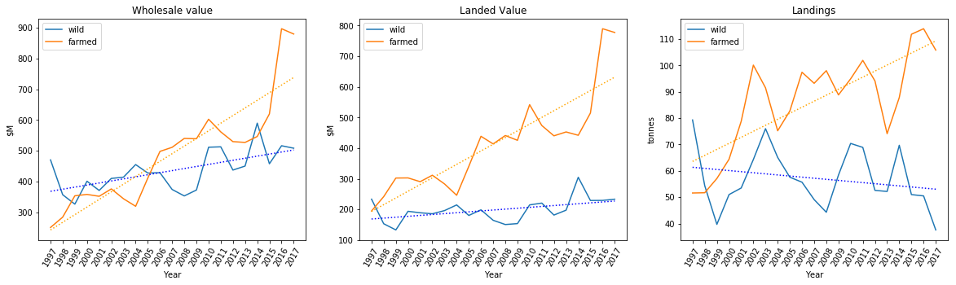

*Figure 1. Wild and farmed seafood statistics from 1997 and 2017. OLS regression lines are dotted.*

1. “World's Fish Supply Running Out, Researchers Warn.” <https://www.washingtonpost.com/wp-dyn/content/article/2006/11/02/AR2006110200913.html>, last accessed 2019-11-21.